Name________________________ Block __________________

Directions: In class we will discuss the following questions. Write thoughtful, well-developed responses. Be prepared to share some of your thoughts during “Night in a Day” on November 22nd. Responses should be a MINIMUM of five sentences each.

- What is something you grapple with or have grappled with in the past? Have your core values and understanding of humanity ever been challenged? Describe the scenario, the dilemma, and to what degree you wrestled with the issue. (Examples: relationship with a family member, friendship dynamics, a change in your life).

____________________________________________________________________________________________________________________________________________________________________________________________________________________________________________________________________________________________________________________________________
____________________________________________________________________________________________________________________________________________________________________________________________________________________________________________________________________________________________________________________________________
____________________________________________________________________________________________________________________________________________________________________________________________________________________________________________________________________________________________________________________________________
____________________________________________________________________________________________________________________________________________________________________________________________________________________________________________________________________________________________________________________________________

2) What is something on a local, national, or global scale that you grapple with.

__________________________________________________________________________________________________________________________________________________________________
____________________________________________________________________________________________________________________________________________________________________________________________________________________________________________________________________________________________________________________________________
____________________________________________________________________________________________________________________________________________________________________________________________________________________________________________________________________________________________________________________________________

__________________________________________________________________________________________________________________________________________________________________
____________________________________________________________________________________________________________________________________________________________________________________________________________________________________________________________________________________________________________________________________

3) What societal conditions allow for evil to prevail over good? Think about the literature you have read first quarter, current events, and your basic understanding of history.

__________________________________________________________________________________________________________________________________________________________________
____________________________________________________________________________________________________________________________________________________________________________________________________________________________________________________________________________________________________________________________________
____________________________________________________________________________________________________________________________________________________________________________________________________________________________________________________________________________________________________________________________________

4. Is it possible for human beings to live in peace?
__________________________________________________________________________________________________________________________________________________________________
____________________________________________________________________________________________________________________________________________________________________________________________________________________________________________________________________________________________________________________________________
____________________________________________________________________________________________________________________________________________________________________________________________________________________________________________________________________________________________________________________________________
5. Is forgiveness always possible?

__________________________________________________________________________________________________________________________________________________________________
____________________________________________________________________________________________________________________________________________________________________________________________________________________________________________________________________________________________________________________________________
____________________________________________________________________________________________________________________________________________________________________________________________________________________________________________________________________________________________________________________________________

Vocabulary words to know. We are providing you with the definition, please make a connection from these words to your OWN life. Be prepared to share your thoughts.

- Ambivalence - “the state of having mixed feelings or contradictory ideas about something or someone.”

- Indifference - “lack of interest, concern, or sympathy”

- Paradox (paradoxical) - “a seemingly absurd or self-contradictory statement or proposition that when investigated or explained may prove to be well founded or true.”

________________________________________________________________

“The Roots and Impact of Antisemitism”

“Race is a human invention. We created it, and we have used it in ways that have been in many, many respects quite negative and quite harmful.”
--Race: The Power of an Illusion

Essential Question: What does learning about the choices people made during the rise of the Nazi Party and the Holocaust teach us about the power and impact of our choices today?
Vocabulary
- Anti-Judaism
- Aryan
- Marginalize
- Race
- Racism
- Paradigm
- Eugenics
- Antisemitism
- Xenophobia
Contrary to the beliefs of many people, past and present, race has never been scientifically proven to be a significant genetic or biological difference in humans. Race is socially, rather than scientifically, constructed. There is only one race: human.
Handout

Overview of Anti-Judaism and Antisemitism
Directions: As you are listening to the teacher read, annotate the text by completing the following steps:
- Circle words that are unfamiliar.
- Put a question mark (?) in the margin in places where you feel confused.
- Stop and answer the questions in the boxes. Underline the place(s) in the text where you found the answer to a question.
Judaism is the oldest monotheistic religion. Throughout much of the faith’s history, Jews lived in territories ruled by other groups. They were often treated as outsiders and blamed for disasters suffered by the societies in which they lived. Continuous rumors, lies, myths, and misinformation about Jews have existed throughout history. Many of them persist in the contemporary world. Often this hatred has led to violence.
In 63 BCE, the Romans conquered Jerusalem, the center of Jewish life. They incorporated ancient Israel, the land where the Jews lived, into the Roman Empire. The Romans were brutal rulers who demanded that those they ruled worship their numerous gods. Jews worshipped only one god. The Romans responded with persecution and violence. They destroyed the center of Jewish life, the temple in Jerusalem, in 70 CE. In 130 CE, the Romans attacked Jerusalem again. They displaced much of the Jewish population from the region that the Jews considered their homeland.
Why did the Romans view the Jews as a threat?

During this period of Roman rule, a new faith, Christianity, emerged from Judaism. Jesus and his early followers were Jews. But as Christianity spread after the Romans executed Jesus, early Christians distanced themselves from Jews. This was partly to avoid being persecuted by the Romans. Christianity and Judaism eventually became separate and competing religions. By the 300s, Christianity became the official religion of the Roman Empire. Jews remained a minority.
Over time, lies and myths developed about Jews. Christian Roman society increasingly portrayed them as
“Other.” They were also blamed for various social ills. Among these myths was the false charge that Jews, not Romans, were responsible for the death of Christ. Another powerful lie charged Jews with associating with the devil.
Throughout the Middle Ages, European Christian armies attacked Jewish communities. Jews were also falsely blamed for causing the Black Death. They were forced in some places in Europe to live in ghettos and wear identifying badges. In other places, they were driven away entirely. This happened in 1492. King Ferdinand and Queen Isabella forced Jews to leave the Iberian Peninsula unless they converted. But in the 1500s, not even conversion was enough to save Jews in Spain. The claim emerged among many Christians that those born as Jews had “Jewish blood.” This claim stated that conversion to Christianity did not change Jews’ fundamental identity.
For what events did Christians blame Jews during the Middle Ages?
What were the consequences for many Jewish communities?

Later in the 1500s, Christians known as Protestants broke away from the Church of Rome. Many Protestants thought that Jews would convert to their new Christian faith. When that did not happen, Protestant leader Martin Luther turned on Jews. He called for synagogues and Jewish homes to be set on fire.
The ideas of the Enlightenment had spread across Europe by the 1700s. Among those ideas was that society could be improved through the use of human reason and science and through the ideals of equality. Between the late 1700s and early 1900s, laws and restrictions that discriminated against Jews were lifted in many European societies. In many places, Jews were allowed to participate more fully in the politics, economy, and social life of the places they lived.
As restrictions on Jews loosened across Europe in the 1800s, Jews became more integrated into European society. Some Jews became successful and visible leaders in a variety of professions, and a few became high-ranking government officials. This sparked a backlash from those who continued to be prejudiced against Jews or felt threatened by their increasing success (even though most European Jews remained poor). False conspiracy theories spread across Europe that Jews secretly controlled powerful governments. The theories also stated that Jews controlled financial institutions and sought to enrich themselves at the expense of non-Jewish Europeans.
How did the Enlightenment ideas impact the treatment of Jews in Europe?

During the same period, the field of “race science” emerged in Europe and North America. This happened in part to portray slavery and other divisions in society as “natural.”
Race scientists who divided humans into separate races began to count Jews as a race. In 1878, German Wilhelm Marr popularized the idea that Jews are a distinct and dangerous race. He called them the “Semitic” race. He believed that this race was assaulting Germany and decreasing the fortunes of true “Aryan” Germans. “Aryans” were a mythical, supposedly superior race. Many northern Europeans believed they had descended from the “Aryan” race. Marr coined the term “antisemitism” to describe his belief that Jews were dangerous and should not be allowed to participate in German society.
How did Wilhelm Marr apply ideas of “race” to Jews? How did “race science” support his view?

Antisemitism became common across Europe in the early 1900s. Jews were falsely blamed for the destruction and defeat suffered by Germany and its allies in World War I. They were also blamed for the communist revolution that overthrew the tsar in Russia. Thus, they inspired fear in capitalist societies cross Europe. These myths and lies were used to justify increasing discrimination and violence against Jews in the twentieth century.

Antisemitism Today
The Origins of the Swastika
The word swastika comes from the Sanskrit svastika, which means “good fortune” or “well-being." The motif (a hooked cross) appears to have first been used in Eurasia, as early as 7000 years ago, perhaps representing the movement of the sun through the sky. To this day, it is a sacred symbol in Hinduism, Buddhism, Jainism, and Odinism. It is a common sight on temples or houses in India or Indonesia. Swastikas also have an ancient history in Europe, appearing on artifacts from pre-Christian European cultures.
However, the work of European linguists and other scholars was taken up by racist groups, for whom the swastika was a symbol of “Aryan identity” and German nationalist pride. This conjecture of Aryan cultural descent of the German people is likely one of the main reasons why the Nazi Party formally adopted the swastika or Hakenkreuz (Ger., hooked cross) as its symbol in 1920. As a symbol, it became associated with the idea of a racially “pure” state. By the time the Nazis gained control of Germany, the connotations of the swastika had forever changed.
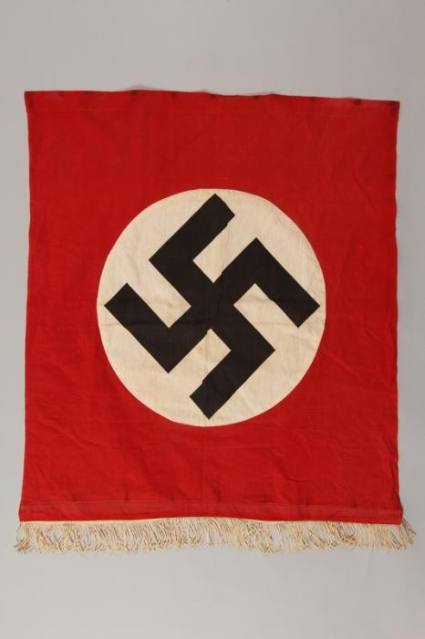 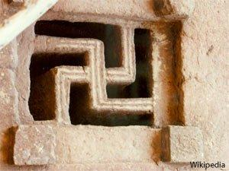
Nazi banner with swastika Ethiopian carved window

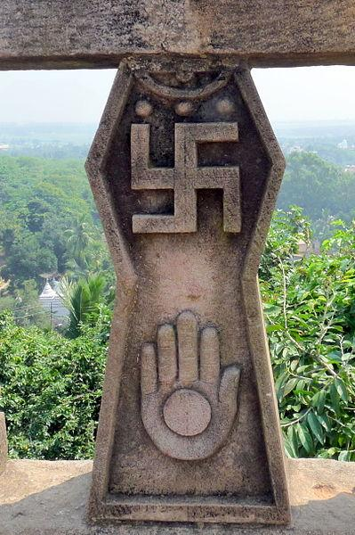

Udaygiri & Khandagiri Caves, Bhubaneswar, India Aztec

How can flags, labels and symbols contribute to the rise of an ideology? How is the swastika used today? How might the use of the swastika be hurtful or inflammatory?

“What hurts the victim most is not the cruelty of the oppressor, but the silence of the bystander.” –Elie Wiesel
Anti-Semitic Incidents
- Assaults: 39 incidents, marking an increase of 105 percent from the 19 incidents reported in 2017. Those incidents affected 59 victims, up from 21 in 2017, and include the 11 fatalities and two injured congregants in Pittsburgh.
- Harassment: 1,066 incidents of anti-Semitic harassment were reported to ADL last year, a 5 percent increase from 1,015 in 2017, and a 48 percent increase from 721 in 2016.
- Vandalism: 774 incidents of anti-Semitic vandalism were recorded in 2018, down 19 percent from 952 in 2017, but up 52 percent from 510 in 2016.

October 27 2018
Eleven victims were killed after a gunman armed with an assault rifle and at least three handguns opened fire during a service at a Pittsburgh synagogue on Saturday morning.

Article and four-minute video:
http://time.com/5438424/pittsburgh-synagogue-shooting-anti-semitism/

March 9 2017
A Michigan man and Holocaust-denier who used Twitter to fantasize about killing school children and Jews will be banned from social media and the Internet for two years under supervised probation terms imposed by a judge. David Joseph Lenio, a 31-year-old self-described white nationalist who said his ideal job would be
operating a human gas chamber, also must undergo mental health treatment and not go within 1,000 feet of schools or Jewish synagogues.
November 8 2018
New York City has experienced a 22 percent increase in bias crimes against Jews so far this year, 159 compared to 130 during the same period of 2017, police reported Wednesday. On Monday, New York police arrested a man charged with scrawling pro-Nazi slogans inside a Brooklyn synagogue a week ago.

Who is Responsible for This Inhumanity?

Directions: In this exercise, you will be determining who was responsible for creating the Holocaust and to what extent they are guilty of crimes against humanity.

Number in sequence from 1 to 10 to the persons listed below according to the responsibility you believe they should bear for the Holocaust. Number 1 indicates the greatest guilt and responsibility; number 10 indicates the least guilt and responsibility. No number may be used more than once.

_____ Residents of Poland who knew about the camps, but did nothing to stop them

_____ Minor Nazi soldiers who carried out the mass extermination orders without questioning superiors.

_____ Hitler, the leader of the German nation who hated Jews and demanded for their destruction.

_____ German citizens who voted for Hitler and the Nazi Party to revitalize their morally and economically depressed country.

_____ The Jews who did not try to escape.

_____ Top SS officers who designed and executed the “final solution” for Hitler

_____ Non-Jewish Europeans who turned against their Jewish friends and fellow citizens for fear that they too would be imprisoned as Jewish sympathizers.

_____ Leaders of the Allied countries who saw evidence of the Holocasut, but refused to get involved or voice opposition to Hitler’s plan of extermination.

_____ Churches of all denominations who remained silent and refused to intervene when confronted with evidence of the Holocasut.

_____ Yahwah, the God of the Jewish faith, who seemed absent and silent during this destruction.

Task:
Has anyone ever asked, “Who are you?” That’s a difficult question, right? When it is not easy to describe ourselves in words, oftentimes pictures and symbols can do a better job.

For this project, create a poster that shows your identity. You may decorate it with pictures, illustrations, cutouts from magazines, words, objects, etc.

Guidelines:
- Completed project needs to be standard paper sized (8 ½ x 11)
- If you choose to leave your name off of the front, have it written on the back
- Each of you will describe the content of your poster in class.
- Items can be related to your:
family
religion
hobbies
talents
feelings
hopes
history
anything that shows us who you are
Format should show your outer identity – who you show to the outside world – and the parts that are most inner and important. Represent the two with this format:
Whatever you use on the poster should not be an irreplaceable object or picture. We are going to display these and I do not want you to lose something valuable.

Due date: This is due on November 22nd at the beginning of the assembly.

Name____________________________________ Project Page

Adapted from Teaching Holocaust and Human Behavior from Facing History and Ourselves https://www.facinghistory.org/about-us
http://newsreel.org/video/RACE-THE-POWER-OF-AN-ILLUSION

